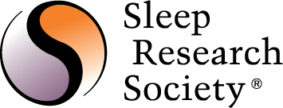

Nomination Form for the SRS
Public Service Award

The SRS Public Service Award is presented to those individuals who have made significant and extraordinary contributions to the mission of SRS above and beyond research and educational activities. Examples include public relations and advocacy, developing government relationships, and public policy efforts, but excludes service on SRS Board (past Board members are eligible, but service on the Board is not considered a part this award).

Please email all nominations to the SRS Coordinator, at coordinator@srsnet.org.

Name of Nominee:
Contact Information (Address, email, phone):

Name of Nominator:
Contact Information (Address, email, phone):

Please specifically and succinctly describe the outstanding public service and its impact or significance to the sleep and circadian field (no more than 300 words):

