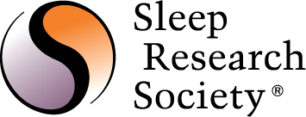

Nomination Form for the SRS
Outstanding Scientific Achievement Award

The Outstanding Scientific Achievement Award is presented to individuals to recognize novel and seminal research dealing with a specific thematic area (not a collection of disparate findings) that has made a significant impact to the sleep and circadian research field. Generally, the major contribution is presented in a single publication, although in some cases the scientific contribution is best represented in a small series of discoveries. Scientific advances recognized by this award may be basic, translational, clinical or theoretical in nature. This award honors one scientist or a team of up to three scientists most responsible for the design, conduct, and publication of the novel and seminal work.

Please email all nominations to the SRS Coordinator, at coordinator@srsnet.org.

Name of Nominee:
Contact Information (Address, email, phone):

Name of Nominator:
Contact Information (Address, email, phone):

Please provide the citation(s) or a PDF of the publication with this form.

Please specifically and succinctly describe the outstanding research contribution and its impact or significance to the sleep and circadian field (no more than 300 words and no other documentation than that requested above):

